Regulations:
A17

H.T No

Sreenidhi Institute of Science and Technology
(An Autonomous Institution)
Code No: 6A201 Date: 31-May-2018 (FN)

B.Tech I-Year II-Semester External Examination, May/June - 2018 (Regular)
CIRCUITS AND NETWORKS – I (EEE)

Time: 3 Hours Max.Marks:75

Note: a) No additional answer sheets will be provided.
b) All sub-parts of a question must be answered at one place only, otherwise it will not be valued.
c) Missing data can be assumed suitably.

Part - A Max.Marks:25

Answer all QUESTIONS.

1. | Define and explain Kirchoff’s current law. | [3M]
2. | Define i) Graph ii) Branch iii) Tree | [3M]
3. | State Faraday’s laws of electromagnetic induction. | [3M]
4. | Define form factor. | [3M]
5. | Write the relation between Q factor and bandwidth. | [3M]
6. | Define Tellegen’s theorem. | [2M]
7. | Differentiate between series and parallel network. | [2M]
8. | Define RMS value of AC waveform. | [2M]
9. | State the Milliman's theorem. | [2M]
10. | Define resonance. | [2M]
Part – B Max.Marks:50
ANSWER ANY FIVE QUESTIONS. EACH QUESTION CARRIES 10 MARKS.

11. | a) | The current waveform i(t) is passed through series R-L circuit with R=2Ω and L=2mH as shown in Fig.1. Find the voltage across each element and sketch the same.  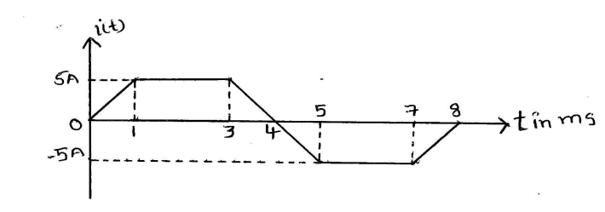 Fig.1 | [5M]
 | b) | Find the equivalent resistance across the terminals A and B in Fig.2.  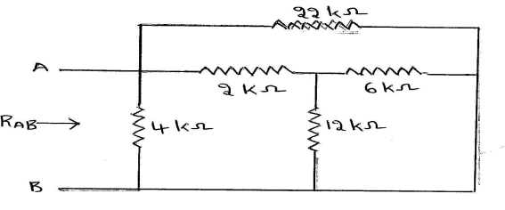Fig. 2 | [5M]
12. | a) | Write the cut-set and tie-set matrices for the graph shown in Fig.3.  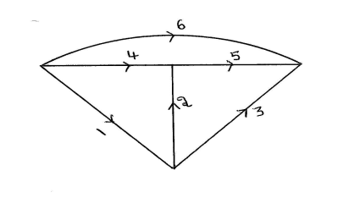 Fig. 3 | [5M]
 | b) | Draw the graph for a parallel RLC circuit and determine the cut-set matrix for the graph by taking necessary assumptions. | [5M]
13. | a) | Explain the concept of self and mutual inductance. | [5M]
 | b) | Derive the equation for coefficient of coupling. | [5M]
14. | a) | A series circuit containing of 25Ω resistor, 64mH inductor and 80µF capacitor is connected to a 110V, 50Hz, single phase AC supply. Calculate the current and voltage in each element. | [5M]
 | b) | Draw the power triangle and explain active, reactive and apparent powers. | [5M]
15. | a) | Draw the locus diagram of series RC circuit and explain. | [5M]
 | b) | Define the bandwidth and derive the expressions for bandwidth of series resonating circuit and its relation with Q-factor. | [5M]
16. | a) | State and explain Thevenin’s theorem and find the voltage ‘V’ in the circuit  shown in Fig.4  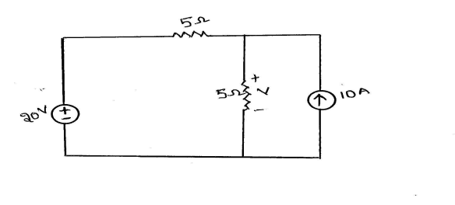Fig.4 | [5M]
 | b) | State and explain Maximum power transfer theorem and derive the condition for maximum power transfer from source to load. | [5M]
17. | a) | Explain different types of network elements. | [3M]
 | b) | Differentiate between electrical and magnetic circuits. | [3M]
 | c) | Explain about Cut-set and Tie-set matrix with an example. | [4M]
18. | a) | Explain Impedance triangle. | [3M]
 | b) | Differentiate between series and parallel resonance circuits. | [3M]
 | c) | State and explain superposition theorem. | [4M]
-- 00 -- 00 –

